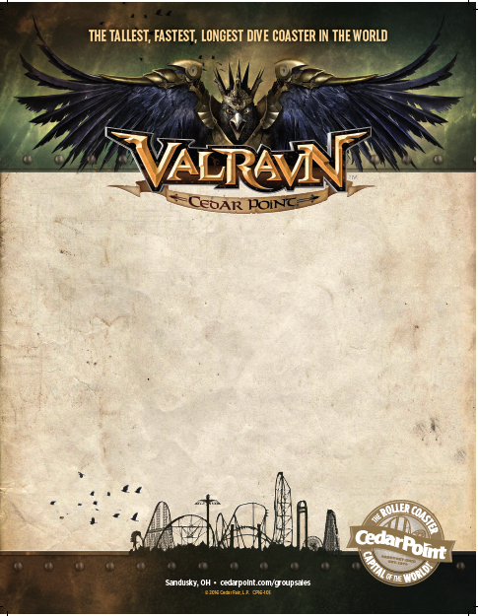

**UAW LOCAL 1050**

RECREATION COMMITTEE

CEDAR POINT DISCOUNT TICKETS

**$38.00** EACH 3 & OVER

**$12.50** Parking Voucher

**$8.00** Drink Wristbands

Discount Dates are either July 5, July 16 or August 13, 2016.

We are also selling “Good Any Day Tickets” that are for using any day of this season for $49.00 each.

Please contact **Tammy Akers (440) 670-3777** or **Donna Gibson (440) 213-5481**

For discount tickets.